**EXP NO 1: Configuration of Network Devices using Packet Tracer tools(Hub, Switch, Ethernet, Broadcast).**

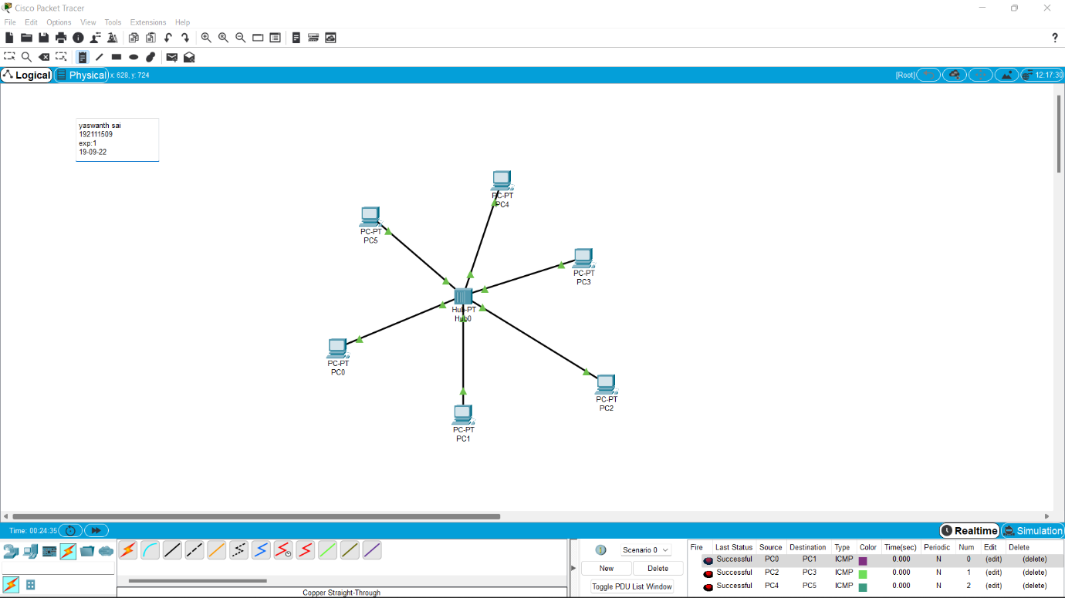

EXP NO 2: **Configuration of Topologies using Packet Tracer (Star, Bus, Ring)**

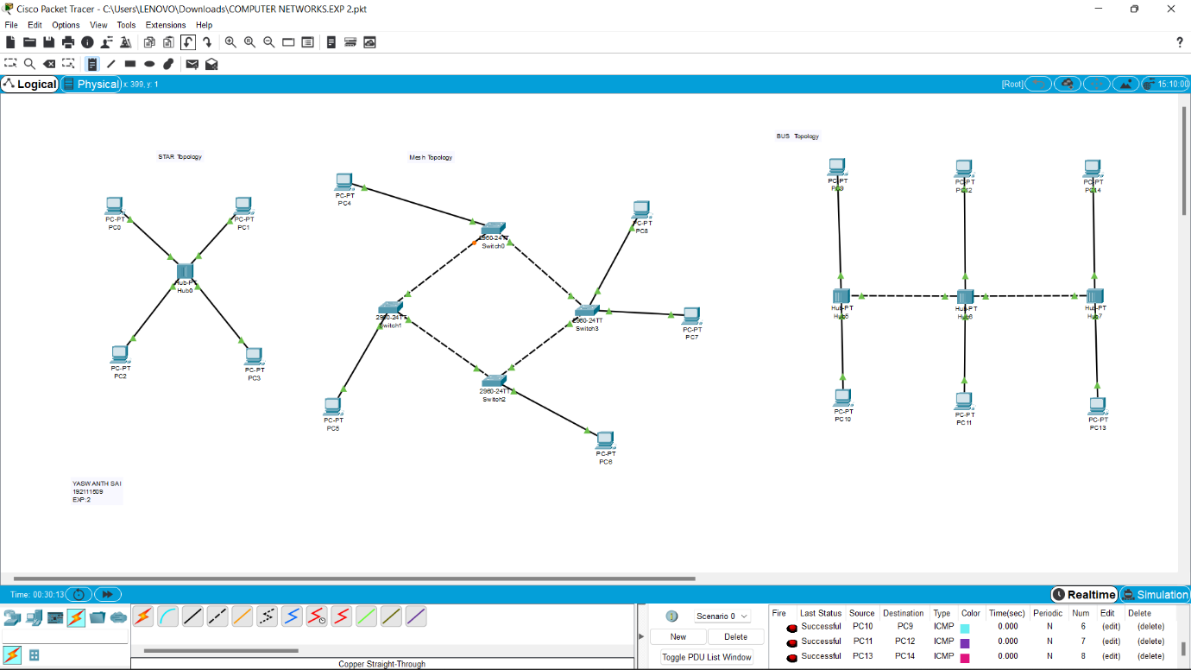

EXP NO 3: **Configuration of Topologies using Packet Tracer (Mesh, Tree ,Hybrid)**

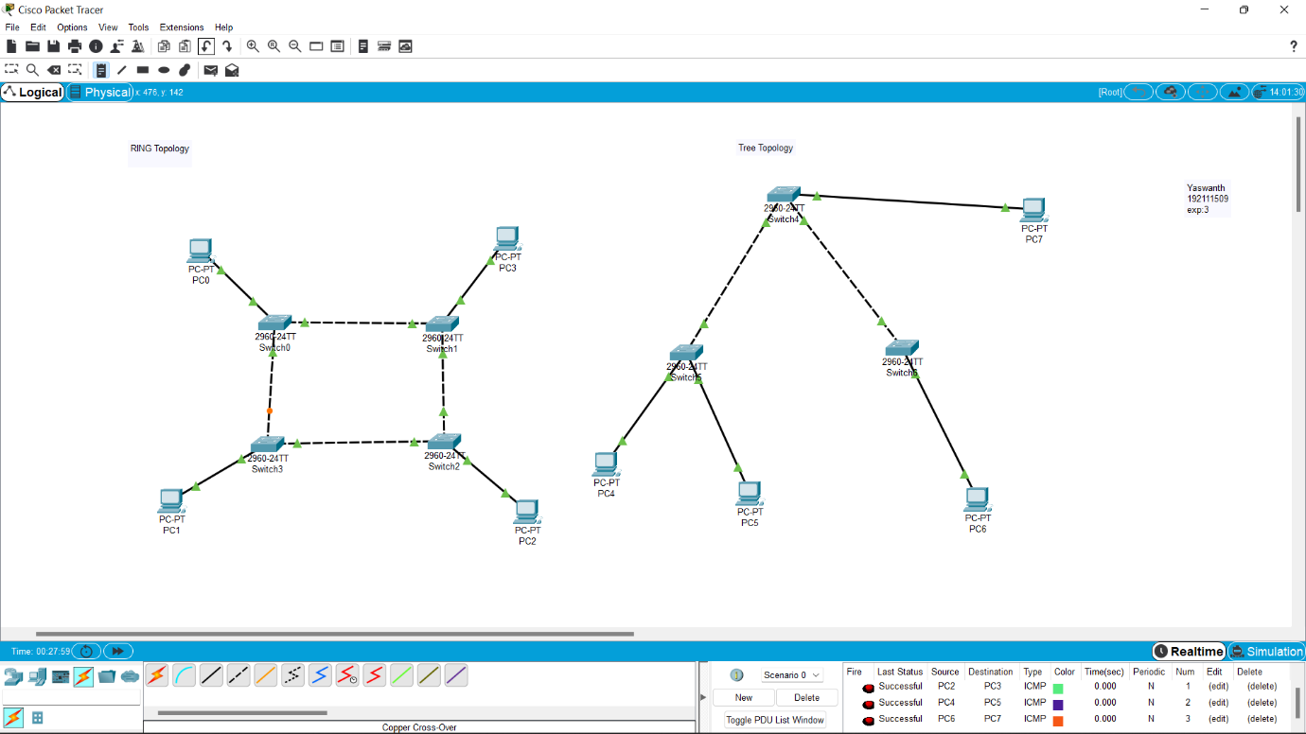

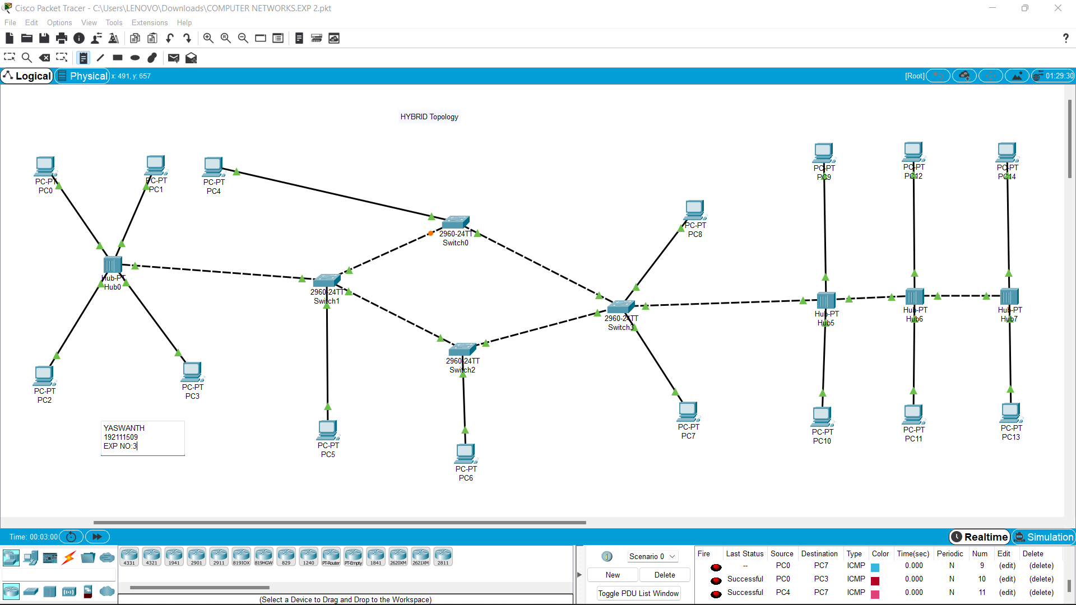

EXP NO 4: **Data Link Layer Traffic Simulation using Packet Tracer Analysis of ARP**

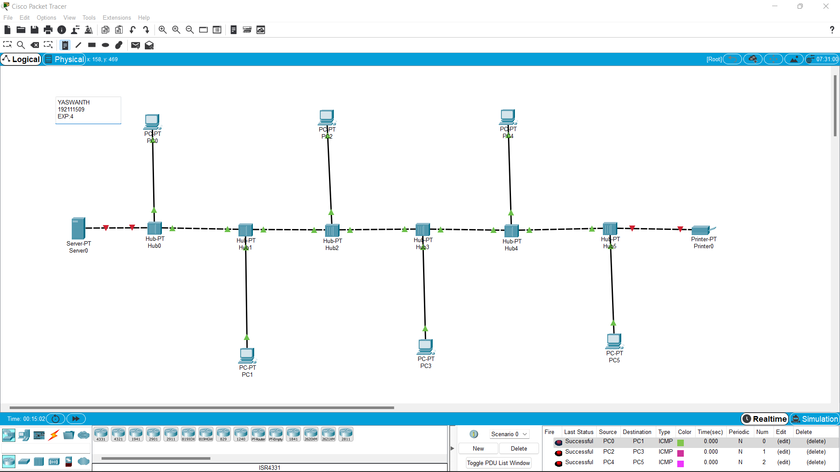

EXP NO 5: **Data Link Layer Traffic Simulation using Packet Tracer Analysis of LLDP**

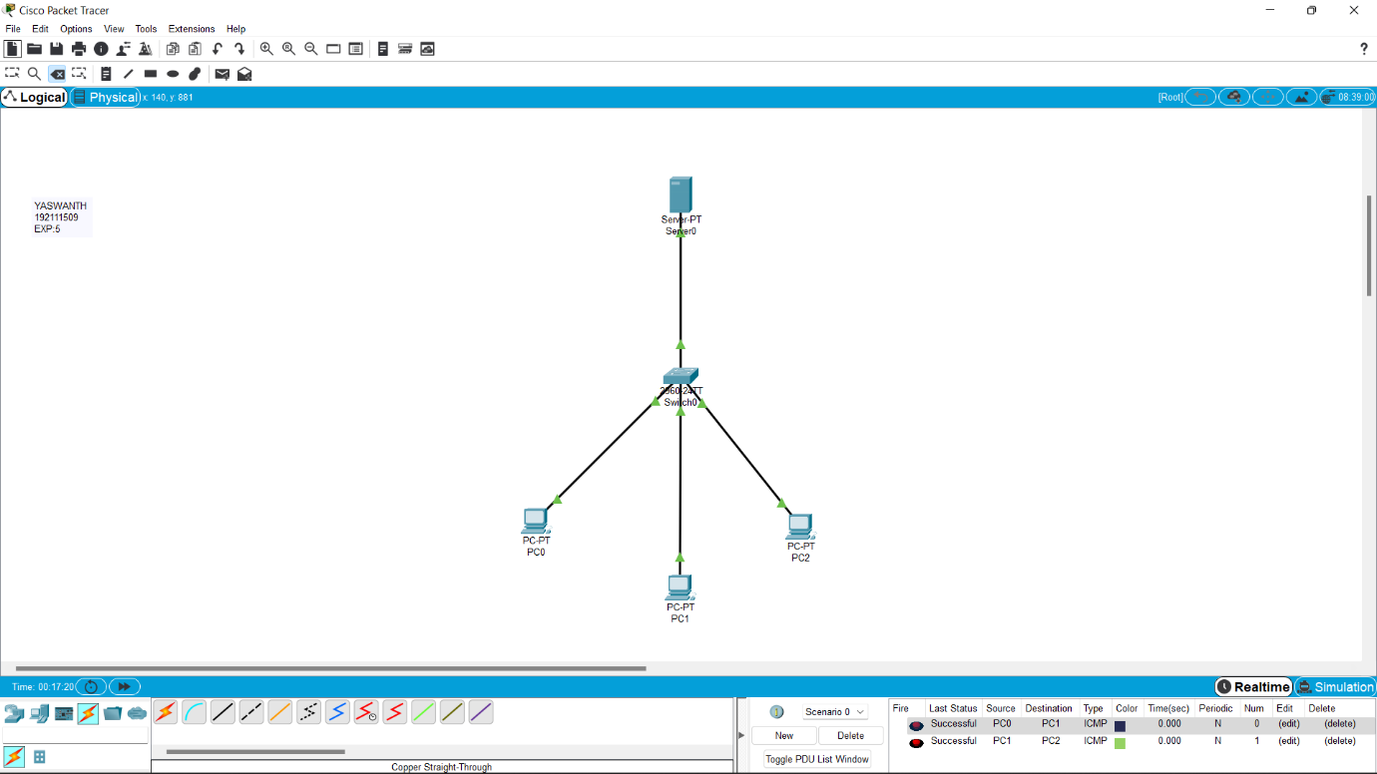

EXP NO 6: **Static Routing using Packet Tracer**

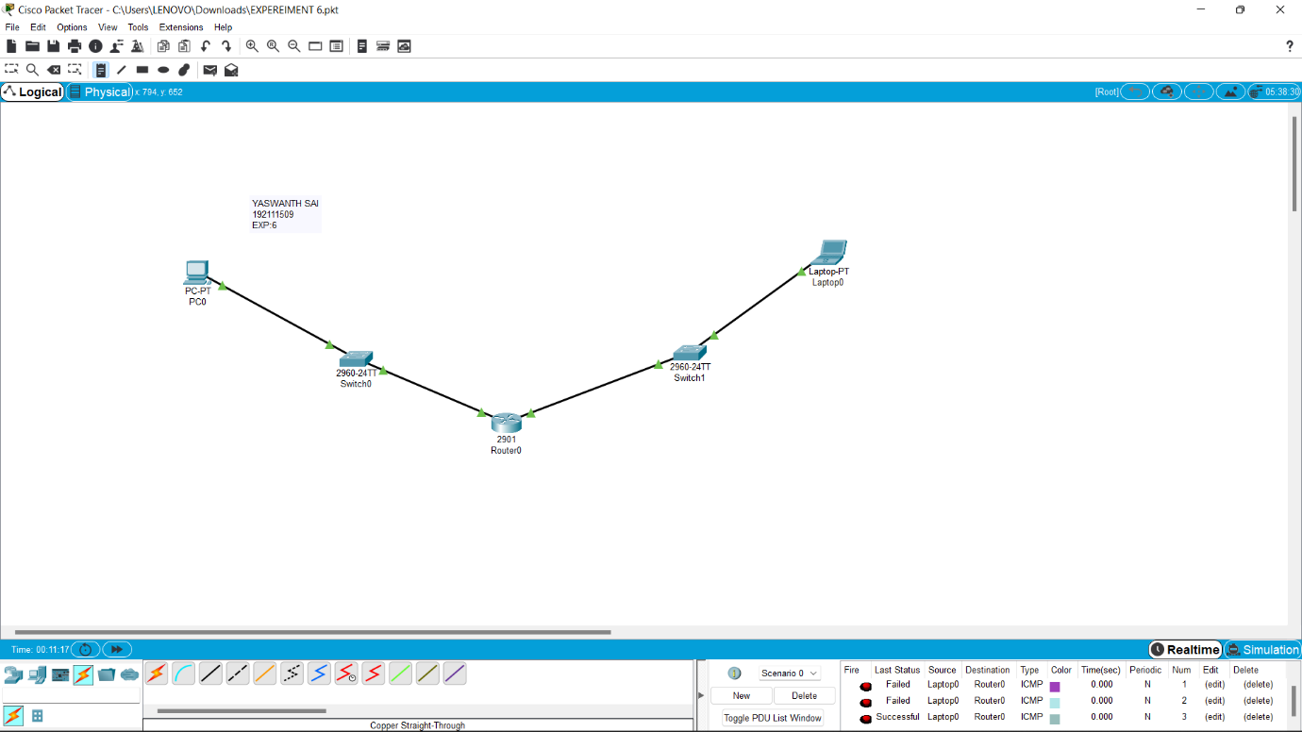

EXP NO 7: **Dynamic Routing using Packet Tracer (Distance vector & OSPF)**

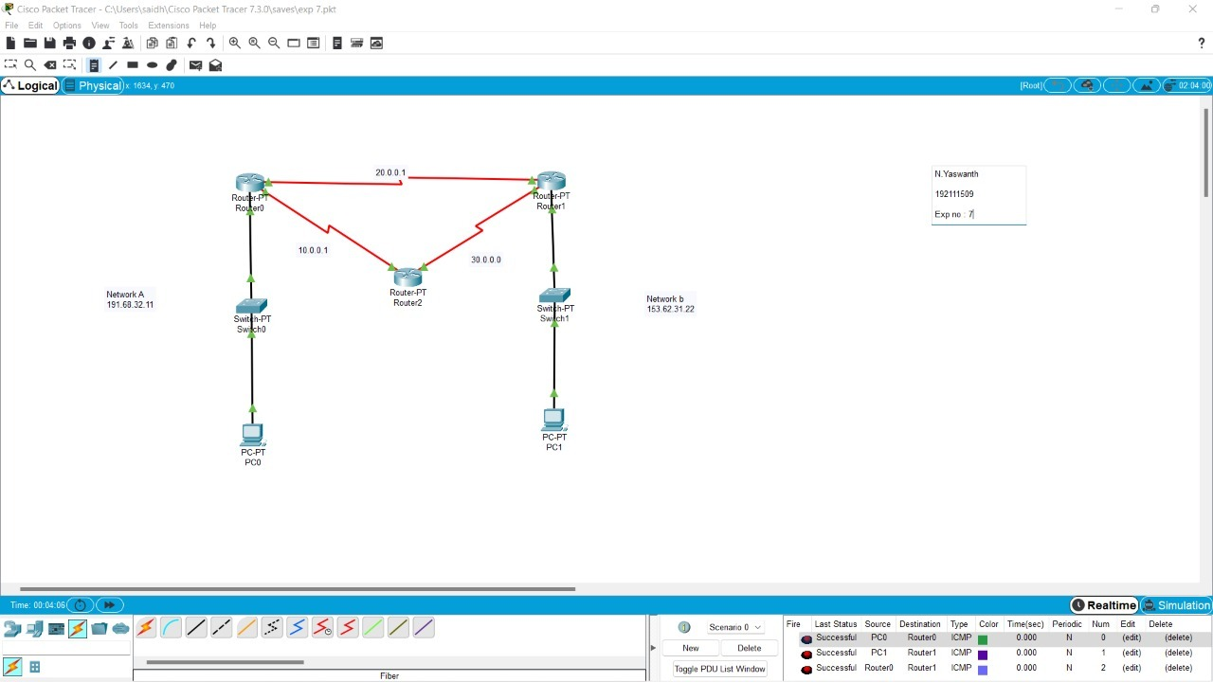

EXP NO 8: Subnetting – Class C Addressing

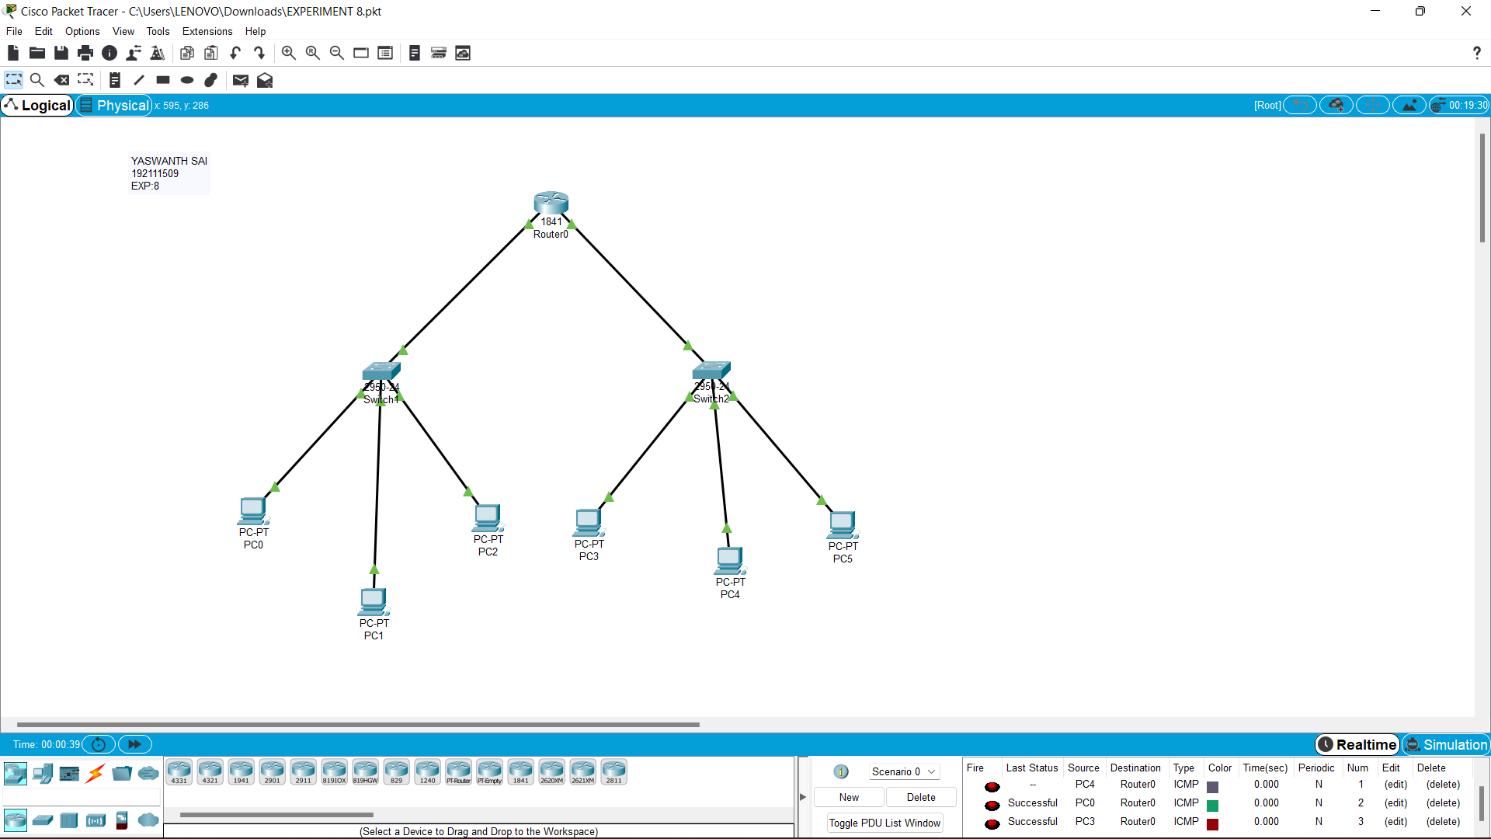

EXP NO 9: Functionalities of TCP, UDP

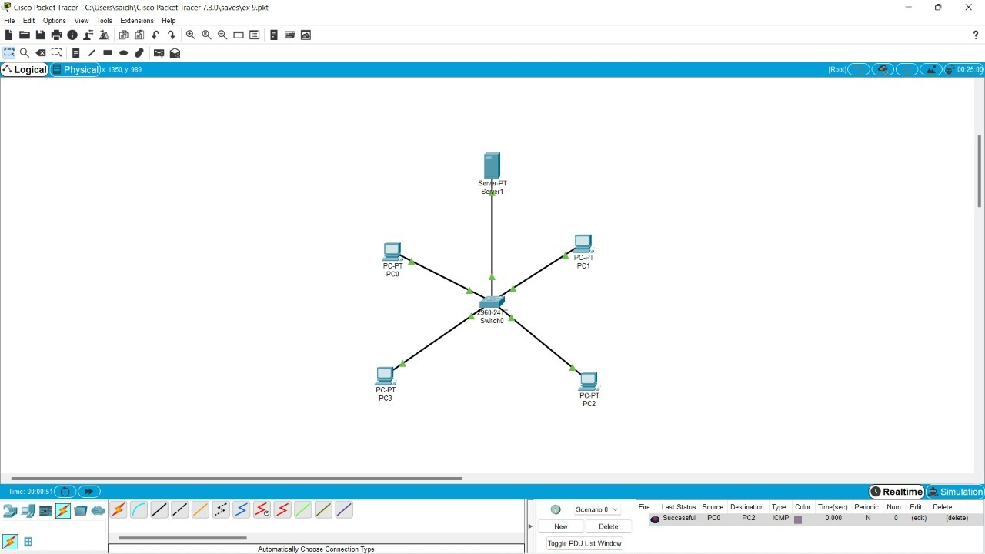

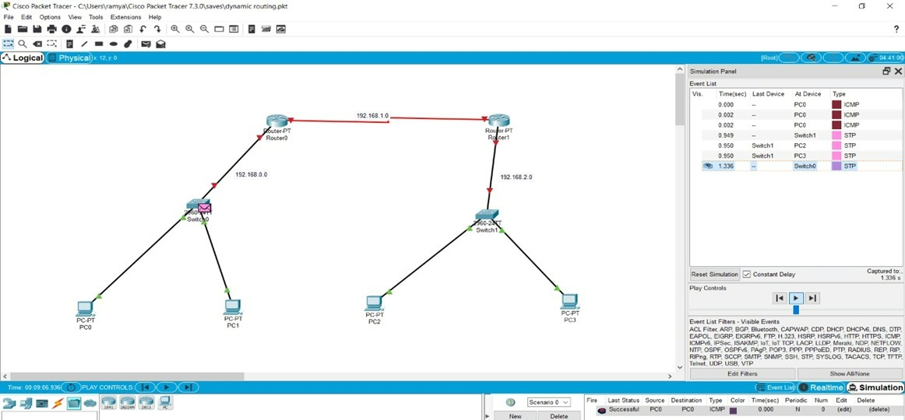

EXP NO 10: TCP, UDP Exploration Solution



EXP NO 11: IOT Based Smart Home Using Cisco Packet Tracer

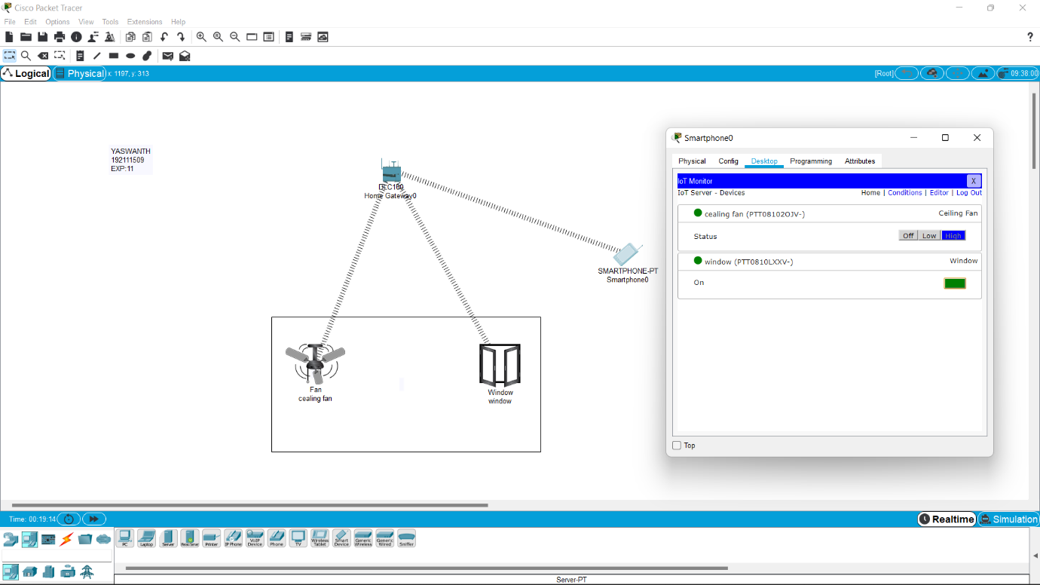

EXP NO 12: Smart Garden in Cisco Packet Tracer

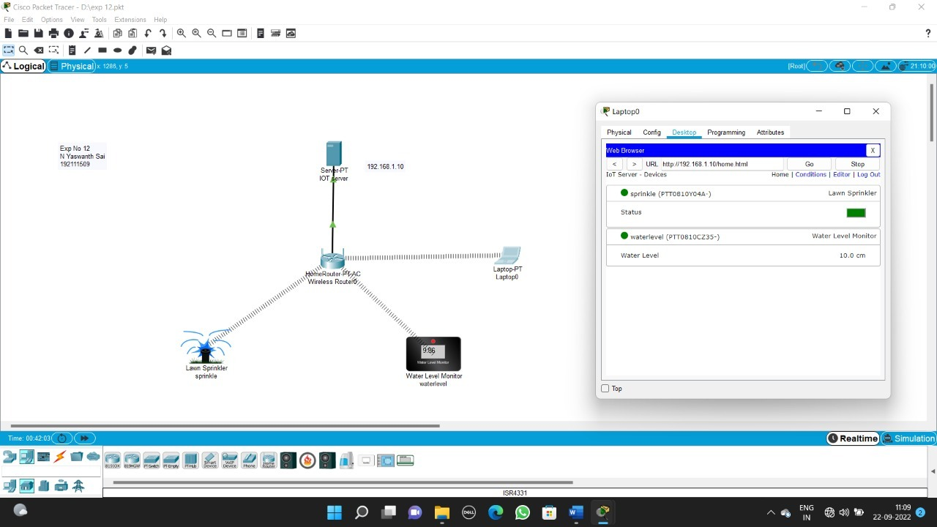

EXP NO 13: IOT Devices in Networking Using Cisco Packet Tracer

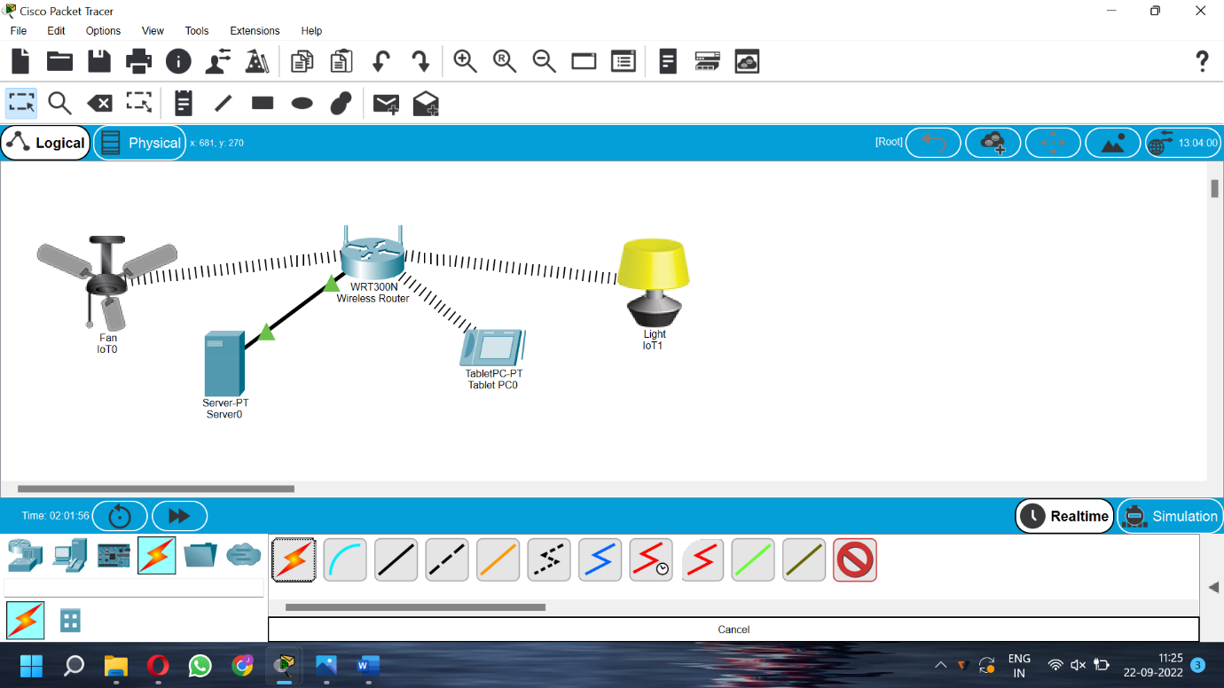

EXP NO 14: Simulating X,Y,Z Company Network Design

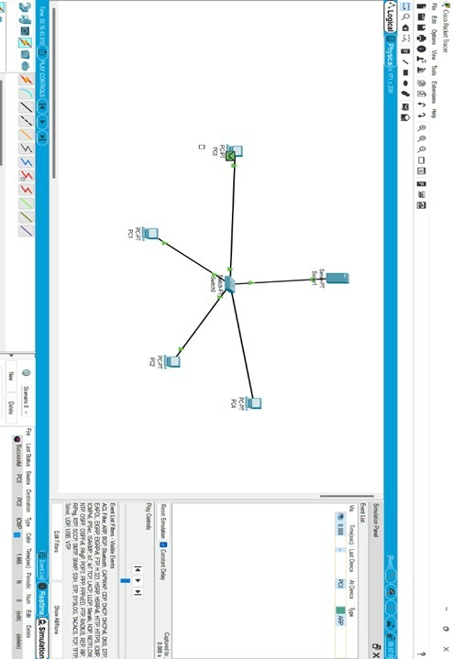

EXP NO 15: Make Computer Lab in Cisco Packet Tracer

